**TestComplete Creating a project**.

1. Open TestComplete.
2. Select File.

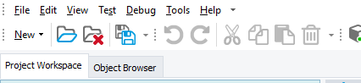

1. Click on New >New Project Suite.

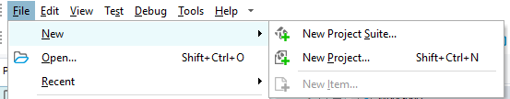

1. A popup will prompt give the project suite name in that. And click on OK.

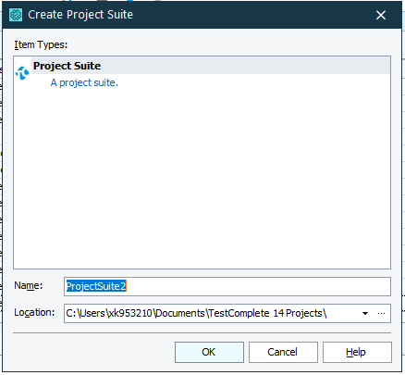

1. The project suite will be created.

**TestComplete Web Framework:**

1. Design

* Below is the framework structure.

1. Execution
2. Reports